The ida pro(free version) we use don’t have debug function. You can use other tools for debugging

For example , x64debug <https://sourceforge.net/projects/x64dbg/files/snapshots/>

Debugging is very useful in solving the problem of “pop-up”, you can simply set breakpoint to find the exact function which execute the pop-up , then you can change the path to avoid this function

If you use x64debug to open the winEdt.exe, you will see addresses which starts with 0x77

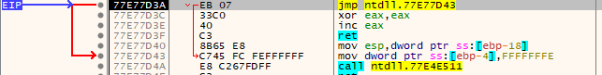

it’s because it’s in a windows function library, you should use “run to the user mode” to go to the address space of WinEdt.exe

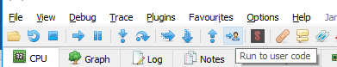

Then you can set breakpoint by clicking the dots besides instructions

